|  |
| --- |
| [Type the document title] |
| [Type the document subtitle] |
| Ntsako |

Question 1

Q.1.1 create view NormalResults AS

select P.Patient_Name, P.Patient_Surname, D.Docter_Surname, TR.Test_date, TR.Test_Result

from Patients as P, Test_Results as TR, Docters as D

where P.Patient_Id = TR.Patient_Id and TR.Docter_Id = D.Docter_Id and TR.Test_Result < 7.8;

select * from NormalResults;

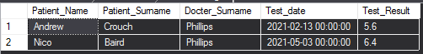

Q.1.2 create procedure PatientRecord @Patient_Id varchar(5)

As

select D.Docter_Surname, TR.Test_date, TR.Test_Result

from Patients as P, Test_Results as TR, Docters as D

where P.Patient_Id = @Patient_Id and TR.Patient_Id = @Patient_Id and D.Docter_Id = TR.Docter_Id;

EXEC PatientRecord @Patient_Id = 'PT001';



Q.1.3 select distinct D.Docter_Id, D.Docter_Surname, IIF(TR.Docter_Id is null, 'No Patients Referred', 'Patients Referred') as 'REFERRALS'

from Test_Results as TR

right join Docters as D

on Tr.Docter_Id = D.Docter_Id

left join Patients as P

on TR.Patient_Id = P.Patient_Id;

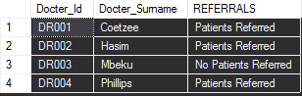

Q.1.4 select P.Patient_Name, P.Patient_Surname, AVG(TR.Test_Result) as 'Overall Average'

from Test_Results as TR

right join Patients as P

on TR.Patient_Id = P.Patient_Id

group by P.Patient_Name, P.Patient_Surname

order by 'Overall Average' desc;

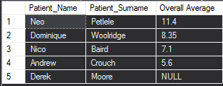

Q.1.5 select p.Patient_Name, P.Patient_Surname

from Test_Results as TR

right join Patients as P

on TR.Patient_Id = P.Patient_Id

where TR.Patient_Id is null;



Question 2

Q.2.1 create table Customers(

Customer_Id varchar(10) not null primary key,

Customer_Name varchar(50) not null

);

create table Equipment(

Equipment_Code varchar(5) not null primary key,

Equipment_Name varchar(50) not null,

Hourly_Rate smallmoney not null

);

create table Equipment_Bookings(

Customer_Id varchar(10) not null,

Equipment_Code varchar(5) not null,

Booking_Date date not null,

Hours smallint not null,

Deposit_Paid smallmoney not null,

foreign key (Customer_Id) references Customers(Customer_Id),

foreign key (Equipment_Code) references Equipment(Equipment_Code),

primary key(Customer_Id, Equipment_Code, Booking_Date)

);

